Introduction
It doesn’t matter where you work and what your job role is, if you work with other people together as a team, you will always encounter the same challenges:
- Unclear goals and miscommunication that cause busy work and extra effort
- Unstructured meetings that leave participants tired, confused and without clear outcomes
- Frustration builds up because internal challenges to getting the word done are not addressed
- Sudden changes in priorities lead to a loss of focus and momentum
- Muddled compromise takes the place of clear decision making, leaving everybody to come up with their own interpretation.

In short, a lack of structure leads to a waste of time and effort, projects that drag on for too long and frustrated, burnt out teams.

One of the big elements in our work life is the second bullet above – meetings. Meetings are an important and necessary part of working life but how can we do our best to ensure our meetings do not leave participants tired, confused and without clear outcomes?

How do we help meetings work for us?

DO Streamlining Meetings comes from a bunch of work done through Work Smarter Together, the USM-supported Remote Working Group, and UCD Agile.

What follows, and the associated Mural Template for running a workshop on this, are meant to help you think about the ‘How do we help meetings work for us?’ challenge (the concepts) and to give you some things you can do to address it (actions).

How long will it take to do a DO Streamlining Meetings workshop with my colleagues.

This depends on the on the number of meetings you are looking at, the size of the group and whether this is your first time or now. If it is the first time you have come together to do this, allow perhaps an hour and a half – there will be plenty that is new and some parts of the conversation will not have happened like this before.

But be sure to keep the structure in mind and keeping progress through it – you want this DO Streamlining Meetings meeting to feel streamlined!

The timings shown in the sections below are just for guidance.

All the sections give you a ‘section guide’ on what to do in the section and why. Any additional comments provided can be of interest when you are getting familiar with this.

A quick note on some symbols used
 | We use this symbol to tag ideas or theory.
 | We use this symbol where workshop work is required.

Working in the ‘distributed office’: DO

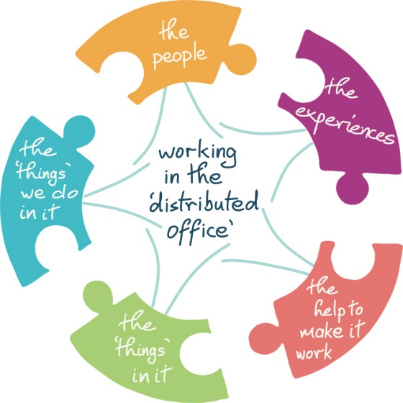 |  | The people  who we work with and the people we connect with
The ‘things’ we do
the tasks and actions that are our work
The ‘things’ in it
the practical things we require to make that work possible
The experiences
what happens through all the connecting, meeting, and working with folks
The help to make it work
what we draw on from outside the office to make the work of the office possible.
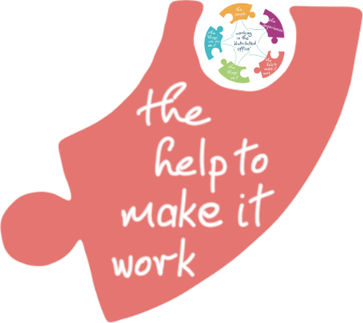 | The DO series of actions and workshops  DO Streamlining Meetings is part of our series of ideas, actions and workshops aimed at helping to make working in the ‘distributed office’ easier.  DO Streamlining Meetings touches on the ‘things’ we do in the office, the people we work with and the experiences we create through this.

Do Streamlining Meetings – the basic concepts
- Meetings are a precious resource
Our time, energy, Zoom tolerance, commitment, capacity to take part etc. are limited resources. How can we use them well?
- There are different kinds of meeting
We need to recognise the kind of meeting we are planning, or are in, or are about to attend, in order to be get the most from it… and in order to streamline it, if that is ours to do.
- People are different
We all ‘know’ the difference between introverts and extroverts, between the tentative and the dominant, between the brief and the verbose, between those who leap in and those who stand back… In running meetings, what do we do with this ‘knowing’? How do we use this insight as a chair or as a participant?
- Meetings should have a purpose and outcomes
Some meetings are get togethers and the outcome is that we had a good time. That is great! But even then, the purpose and outcome should be clear, though you might not call it that for fear of killing the mood. Meetings need a clear purpose. They need desired outcomes. These two determine who attends and how you will run the meeting. If you do not have clarity of purpose and outcomes, you cannot be sure who should attend and you cannot be sure how to carry out the meeting.
- You do not need meetings for everything
“Let’s have a meeting!” That feels like we are doing something but it may be just another way of avoiding doing what we know needs to be done. Do you need a meeting to achieve the outcomes you desire? If meetings are a precious resource, are there better ways than a meeting to get what you need?
- Meetings need a process… even if you do not call it that
For many meetings there will be the preparations beforehand, the running of the meeting itself, and the follow ups afterwards. That is a process. Some meetings need a particular flow to get their outcomes (e.g. a Programme Exam Board). A clear agenda, well chaired, is a process. “Let’s get together and see if we can sort this out…” is not so much a process as a leap of faith. Good luck!
- Different behaviours fit different kinds of meeting
We know our purpose, we know the outcomes we want, we know the kind of meeting we need for this, we know how the meeting should work – how do we give everyone the opportunity to take part? After all, that is why we are all here – our participation is needed in order to make the meeting a success.

What does DO Streamlining Meetings give you
These ideas
The workshop
The meeting checklist
The meetings health check

The workshop
So you are thinking of running a workshop on streamlining your meetings? Or you just want a structure to think through where you find yourself with meetings?

Here is the workshop sequence. By the time you have brought your colleagues through this you are down to naming concrete actions to deal with issues you have named together.  - Session outline  - Session approach  - List the meetings  - Capture all the problems  - Brainstorm what ‘good’ is  - Theory: how to look at meetings  - Choose meetings to look at now  - Check meeting health  - Vote on meetings for action  - Decide on specific actions | If you have been to a DO Streamlining Meetings training session you will have seen this approach in training mode – we did not spend as much time on the list, the problem-capture, and the braining storming. These are key steps when running this workshop locally.

This document follows the same sequence and is put together as a guide to this kind of workshopping. You don’t have to use it for that, but it is a useful framework.

Session introduction
This is where you welcome folks to the workshop, set the context, and make sure everyone knows what you are going to achieve – concrete actions addressing current challenges.

Section guide
 | Timing:  5 Minute introduction  Section covers  Why you are looking at streamlining your meetings.  What you hope to get from today.  Ground rules for participation (but, hey, we’ve not looked at how to run a meeting like this yet… we don’t have agreed ground rules... now is the time to talk this through).
 | Issue:  Meetings are a great and necessary part of office life but how often to you think 'great, another meeting'? How often have you had 'if only...' thoughts about a meeting?  "How do we help meetings work for us?
 | Goal:  Use this session to identify concrete things you can do, and the motivation to act on some quick resolutions.  This session also helps you shape your own on-going approach to making meetings work for you and your team

We would all love meetings we attend to be “I’m glad I went to that” meetings. There are three kinds of meeting – in a world full of ‘kinds of…’ lists: meetings I own/run, meetings whose running I can influence, and meetings I attend. |  | If you can influence the running of the meeting then you have a responsibility to try.
If you own the meeting you have a responsibility to make sure it works for those who attend it. | If you attend, but neither own nor influence, good luck. If it works well that’s great. If it works badly there’s little you can do other than make the most of it. But even then you can influence, perhaps, by how you take part and what you look for from the meeting.
This session will give you a way of looking at and analysing some or all of the meetings you are involved in with a view to making them work for you rather than your being a victim of them.

Session approach

You need to let the participants know what they will be doing in the session. This is part of making your role as facilitator work better, helping shape a flow to the meeting and to set expectations on how folks can participate – what you are hoping for and how you are looking to achieve it.

Section guide
Timing:
5 Minute introduction

Section covers
How you are going to run today’s session, so everyone knows what lies ahead in the session.
If you have any breaks planned, or other housekeeping, now is the time to tell them.
This is where you cover behaviours too – how you are enabling participation and what folks need to be thinking about.
When they are busy with Post-its, they work in silence. Everyone has a voice, everyone can contribute, they don’t have to compete to be heard.
The participants are clear that this session is about going from a general desire to streamline meetings to arriving at concrete actions... all within an hour.

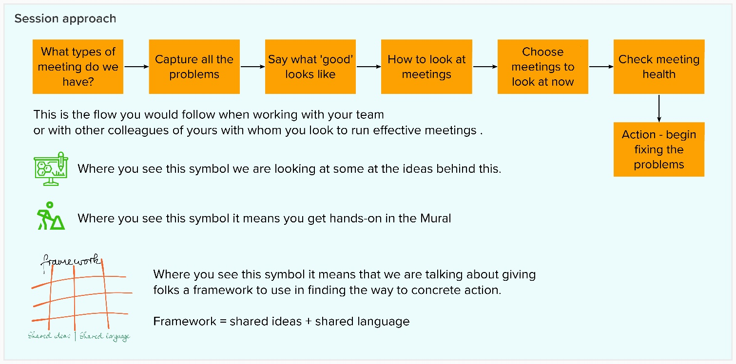

Key point – underlying all of this is the idea of giving your colleagues a framework they can use to slice and dice big challenges into more manageable chunks.
Framework = shared ideas + share language

1 - Identifying the different kinds of meeting

Question: What are the different meetings we attend?
Question: What purposes do the different meetings I attend serve?

Section guide
 | Timing:  12 minutes they are only starting so need a bit of time  2 for you to explain  5 for them to work  5 to talk though the list...and perhaps do a bit of clustering of common types  Section covers:  Listing all the meetings they attend  Getting used to working together  Getting used to the facilitator (you?)  Getting used to using Mural for all of this, or whatever technology you use  Activity  In silence - folks add Post-its to the Mural, one for each meeting they attend.  This is about actual meetings so they should be as specific as they can.  Patterns and types will emerge – the same meeting more than once, the same kind of meeting – so when they are done and you are talking through it, you can cluster the Post-its.

There no ‘correct’ list – this is a way of thinking about real differences between the kinds of meetings you are involved in.

In the training we use the following kinds of meeting as a catalyst. You are looking for the actual meetings your participants attend.

Kind… | What is it like…?
Structured | Agenda, minutes, chair etc.
Problem solving | “What are we going to do about this...?”
Team | “Let’s get together and have a team meeting…”
Process | The meeting is part of a defined process e.g. an Exam Board, interview panel
Planning | Planning
Informal ‘check in’ | “Let’s make sure we keep in touch…”. “How are you / are we?”
Workshops | Part of some bigger process; run for a purpose to get a particular kind of outcome; may be using an established approach
Unstructured | Unstructured a.k.a. miscellaneous, ‘other’, ‘messy’…
Information sharing | Passing on / gathering information. The purpose is met when the information is shared.
Managing staff | One on ones, or with teams, managing they work they do
Managing up | Meeting used in managing up or managing senior stakeholders outside your own area

2 – Capture the problems
Experience: I know a meeting I'm in isn't going well when...
Experience: When I think about 'bad' meetings I've been to, they were...

Use these prompts to get them to explore the problems they have. Folks can sometimes be much more eloquent about problems than about good examples… and you are looking to how you can make meetings better… so encourage them. There may be common kinds of problem – cluster them or get the group to cluster them.

Section guide
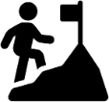 | Timing:  8 minutes  4 to write  4 to go through cluster  Section covers:  Listing the issues folks have with meetings  The more the better – everyone heard.  Activity  In silence - folks add Post-its to the Mural, one for each issue they think of.  They should have particular meetings in their mind’s eye.  Do not name people – that would not be fair – but think about specifics.  Cluster similar points – this usually generates conversation.  It will be interesting to note if some categories of issue get more attention than others. | 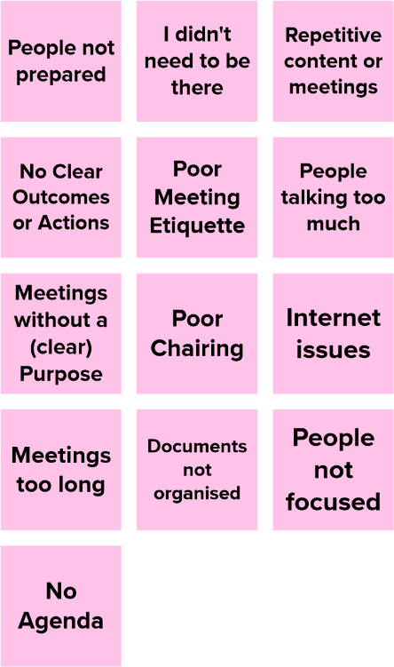  Below are some of the kinds of challenges that are often raised.

3 – Brainstorm what ‘good’ is
Memory: When I've been to a 'good' meeting, it was good because...
Desire: Wouldn't it be great if...

Use these questions as prompts to get them to explore their experience of good meetings. Again, encourage them to think of specific examples. You don’t need to over prompt – they may have lots in mind, and it is not likely they have only had terrible experiences!

If these things are good in meetings, wouldn’t it be great if the future had more of them.

Section guide
 | Timing:  8 minutes  4 to write  4 to go through and cluster  Section covers:  Listing the characteristics of good meeting  Activity  In silence - folks add Post-its to the Mural, one for each ‘good’ they think of.  They should have particular meetings in their minds eye.  Brainstorming! There are no bad ideas.  You are looking for four or five Post-its each. | 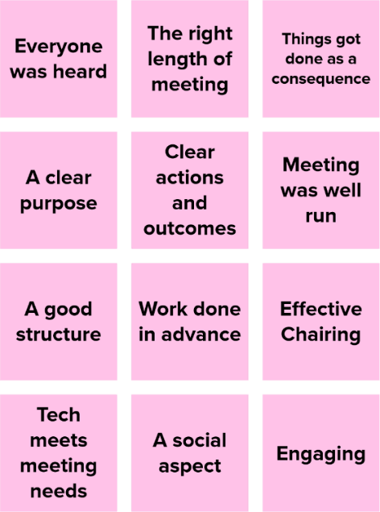  Below are some of the kinds of good experiences folks recalled.

This section is at the heart of the workshop.

There are different kinds of ‘good’ – skills, behaviours, atmospheres, meeting management, supports etc. etc.

What folks name here as ‘good’ are the basis on which meetings get judged, with this becoming part of both how you check whether a meeting is working or not and what you look to put in place in making them better.

4 - How to look at meetings
Section guide
Timing:
5 minutes

Section covers:
Two key concepts at the heart of streamlining meetings

Activity
The facilitator explains the two concepts

The concepts are POPP and ‘ideas – standards – behaviours’.  These provide a framework for looking at meetings – different perspectives, different aspects, more specific opportunities for action.  You are looking to engage your folks in this – that they can see a way to making things better, that they have a language to talk about it, that they share the underpinning ideas. | 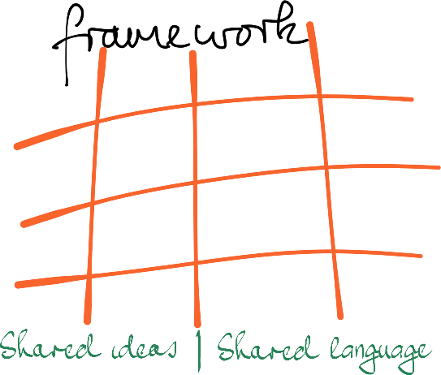

POPP – purpose / outcomes / process /people

POPP is the engine at the heart of going from planning a meeting to running it to the follow up.

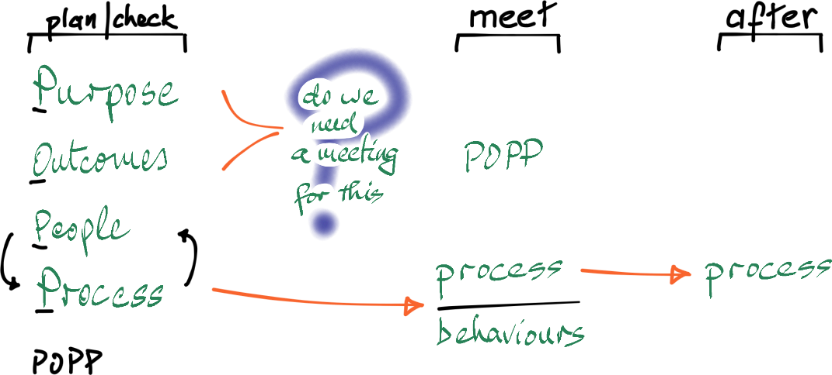

Plan/check

POPP is where you start.

POPP - the four key things you check about a meeting are clarity on the following:

Purpose: Why are we having it?

Outcome: What are we looking to get from the meeting?

Ask: Do we need a meeting for this?

People: Who needs to be there?

Process: How will we run the meeting so as to help these people achieve
this outcome?

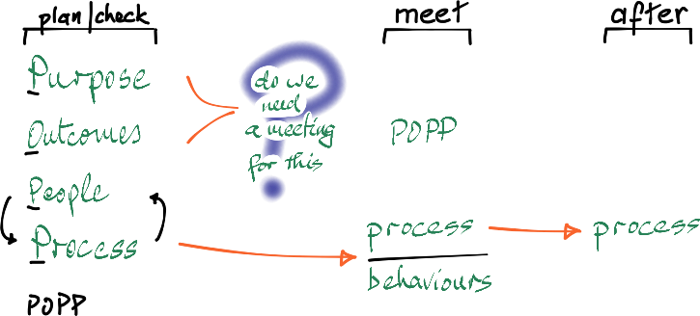
Meet

Whoever is running the meeting needs to stay rooted in POPP. If you are running the meeting and you lose clarity, what are the participants likely to experience?

Now you are running the meeting, how do you help it flow to the desired outcomes? The key is enabling participation.

In terms of ensuring you get what you need from the meeting, how do you help the participants take part?
Agenda used Agendas give structure. They allow meeting flow to be
managed.
They help folks prepare and know what to expect.
Technology used Zoom, Google (Docs, Currents, Keep etc.), Mural etc.
Chairing If there is a chair, their preparation for the meeting, and
setting behavioural expectations, and managing the flow
are key. If you do not have the skill you need help in
developing it.
Behaviour expectations Participants need to know, up front, what is expected and therefore the behaviours to which they can be held to account.
Notes / minutes / actions?

After
The final part is following through. Most folks dislike meetings where they attend but have no idea of what came from the meeting. This saps enthusiasm. And if actions were identified, were they acted upon? Endlessly agreeing to do something and endlessly not doing it also saps enthusiasm.
What happens after?
Did / do actions come from it?
Are actions noted and tracked?
Are they concreate actions, with an owner attached, or aspirations with no specifics?
Do participants get feedback/updates? How do you make the value of their contribution clear?

Ideals – standards – behaviours

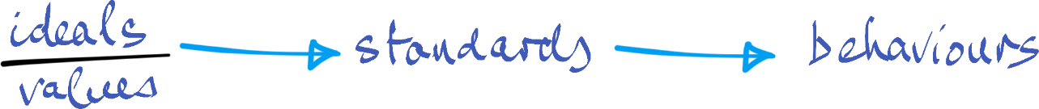

One of the challenges areas that arises is in some folks’ behaviours in and around meetings – not preparing for a meeting, not giving space and room to others to participate, a chair not taking time to prepare properly, doing more talking than listening etc. etc.  People are not always conscious of how they behave or what is expected of them in how they participate in the meeting. Set some standards.  Finding a way to express the expectations can be a challenge if you are looking at addressing issues in a long-standing meeting. It is easier to name expectations when setting up a new meeting or a one-off. And you typically see this guidance on participation given as a matter of course at the start of workshops.  The standards we set come from the ideals we have – around participation (‘everyone has a voice’), around how to make the best use of time (‘our time is precious – let’s make the best use of it), around ensuring meeting flow (‘how do we best ensure we get to the kind of outcomes we are looking for?’)  Setting standards is a way of giving voice to your ideals and a way of shaping the behaviours you would like to see. | In the two workshop sections on challenges and on experiences of good meetings, folks will have, directly or indirectly, talked about values and ideas.  These two sections are important reference points.  You will not dwell too much on this in a first workshop but you should draw them out and reflect them back to the group.

5 - Choose meetings for focus
Vote on which meetings to look further at now.

You only need to vote if the list of meetings surfaced in step 1 is large.

This step lets you narrow the focus a little further.

Section guide
Timing:
4 minutes
2 to re-read the meetings in step and vote
2 to note the pick of the meetings you will work with

Section covers:
Choosing the meetings to look at in more detail.

Activity
The facilitator explains how voting works.
Each participant gets three votes they can use any way they want.
Voters cannot see who is voting for what – anonymous democracy.
The facilitator sets the timer running.
The score comes up at the end.

If there are enough meetings that they cannot all be looked at, then we need some way, fair to the participants, for choosing which ones to look at in more detail.  This is where the silent vote in Mural comes in. The goal is that you help those taking part narrow down the list to ones most folks agree are important. ‘Silent’ means folks do not have to argue for their preference, they can just make it.  The goal is choosing so you can feel tree to take your own approach to how you run the vote, as long as it does not become a discussion. | From a recent session  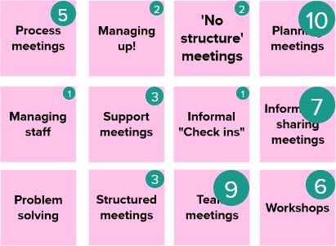

6 - Check meeting health
Now you go through the meetings you chose to look at and see how each of those does for a health score.

Section guide
   | Timing:  15 minutes  3 to explain what you are doing  10 in total to work though the meetings in the list  2 to note and highlight the patterns  Section covers:  Getting the group to look at the health of the meetings chosen.  Activity  Facilitator:  Place each of the meetings being looked at in the ‘meeting’ column.  Go through each to fill in the first two columns:  Own / Influence / Attend; Frequency  Participants:  In silence - get the participants pick one of the three icons to ‘score’ each of the next seven columns. Ctrl C / Ctrl V to copy or Ctrl D to duplicate  When all of the scoring is done do the last column together – the overall health  Now you have a health map of your meetings.

The categories in the health check follow on from what has been covered up to this point in the session.

From a recent session.
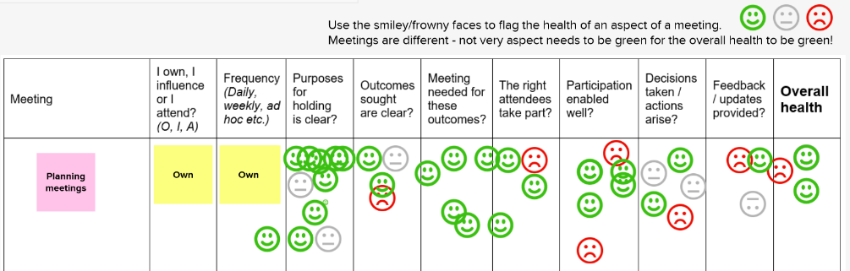

When you do this with all of the meetings you have chosen, you can quickly see the meetings, or the aspects of meetings, which would benefit from further attention.

You have now refined your list even further – highlighting certain meetings, highlighting aspects of them that need to be addressed.

7 - Vote on meetings for action
This is the final refining step if you need to narrow things down further.

The goal of this session is to decide concrete actions that can be taken to make things better. You cannot do everything in one go, so voting gives the group their opportunity to set priorities and choose where first action would be best.

If you vote, do so against the meetings listed in the first column of the health check list in section 6.

Section guide
Timing:
4 minutes
2 to re-read the meetings in step and vote
2 to note the pick of the meetings you will work with
Section covers:
Choosing which meeting get focused on for action.

Activity
The facilitator explains how voting works.
Each participant gets three votes they can use any way they want.
Voters cannot see who is voting for what – anonymous democracy.
The facilitator sets the timer running.
The score comes up at the end.
You now have the meetings you will focus on in deciding actions.

8 - Decide on actions.
The purpose of the session is to get to concrete action – specific tasks done by named individuals in a short space of time.

Depending on how many folks are in the session and how many areas you are looking to develop actions in, you may split folks up into teams to look at individual areas.

You do not want too many meetings to focus on at this point – you cannot really focus on lots of issues at the same time. Three or four meetings is enough.

Section guide
Timing:
15 minutes roughly This will depend on lots of factors from the session
1 to move the meetings chosen for action
2 get folks in teams, if needed
8 to work through the chosen meetings.

Section covers:
Coming up with actions against the chosen meetings. The health check will highlight just what it is about the meeting that needs attention.

Activity
Facilitator:
Copy down the chosen meetings
Setup the teams, if needed
Participants:
Come up with three possible actions for each meeting
When all this is done, go through the actions, checking they are concrete and have a name attached.

If the actions are not concrete... they are not actions but aspirations or hope... “I wish the future would be better... but we are not doing anything concrete to make it so...”

Keep the timeframe short. That does two things – it stops you taking on too much and it makes sure there are concrete outcomes from the session in a useful and practical timeframe.

You can come back later to the list, tick the actions that have been taken, and see what further actions can now be taken.

If you clear the list, you can go back to your health check, and the vote, and see what folks want to tackle next.

Celebrate successful actions. Put a big tick on the list. Give Zoom cheers!

